**Restarting a Server:**

The process for restarting services on a server is very much the same except the Web server which may require more steps to complete. Procedure for restarting the Web server will be provided once it’s available. The following procedure is for restarting App17.

1. Log into Barracuda (10.1.103.30) – Primary.
2. Put PSNApp17 (10.1.106.17) out of rotation by clicking Disable.

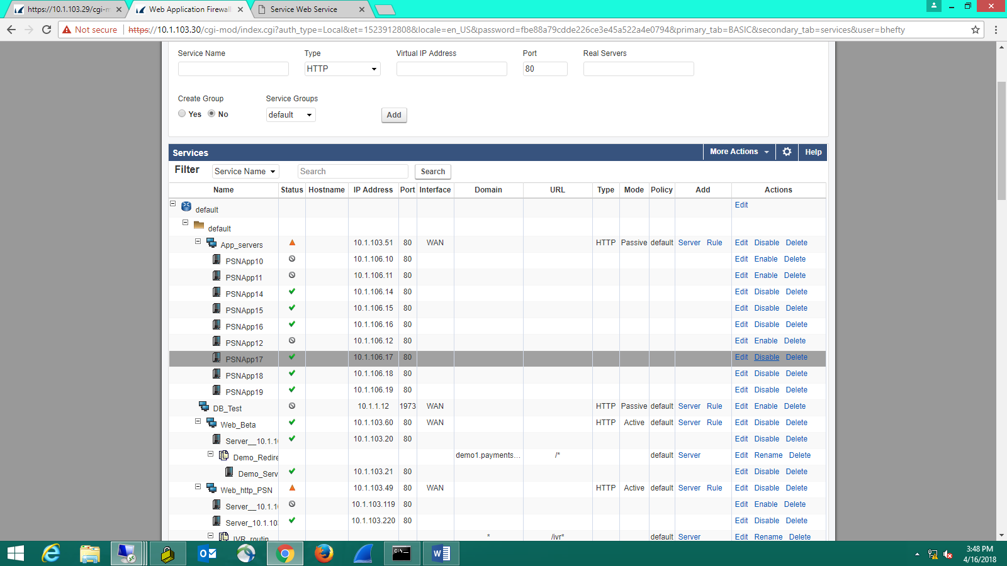

1. Once PSNApp17 is out of rotation then Log into the 106.12 box and stop the PSNMonitor service in the Task Manager.

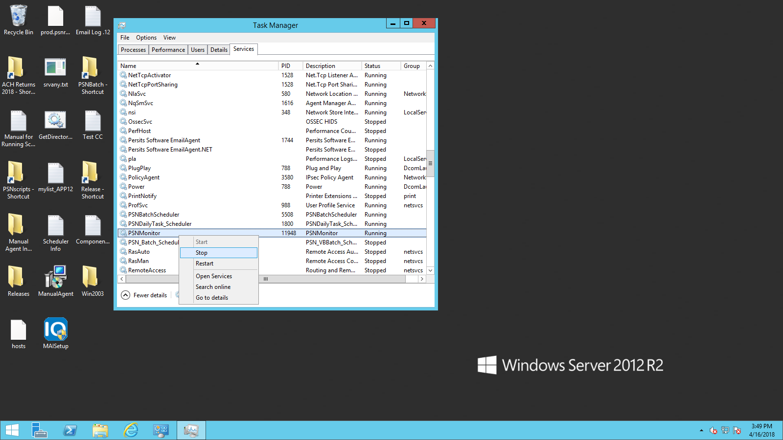

4. Log into the APP server and restart it.

5. Once it comes back up, then open the services and make sure there are three IIS Workers listed. Also, the memory usage should also increase at that point.

6. Another test is to open your browser and go to 10.1.106.17/Service.asmx. If you see succeed, then it’s up.

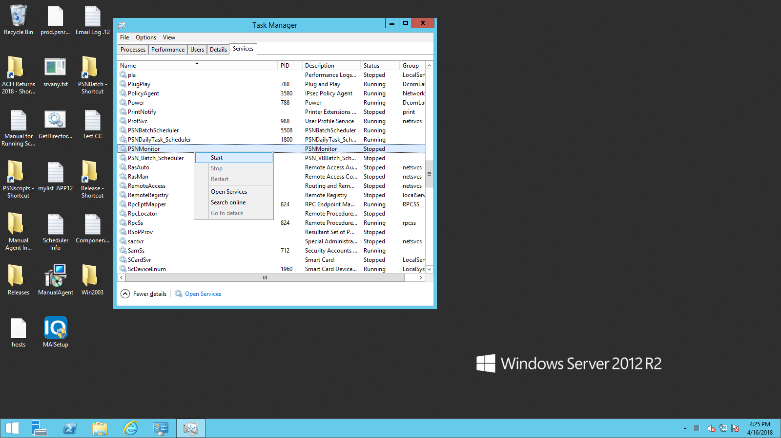

7. Now, log back into the primary Barracuda and put PSNApp17 back in rotation.

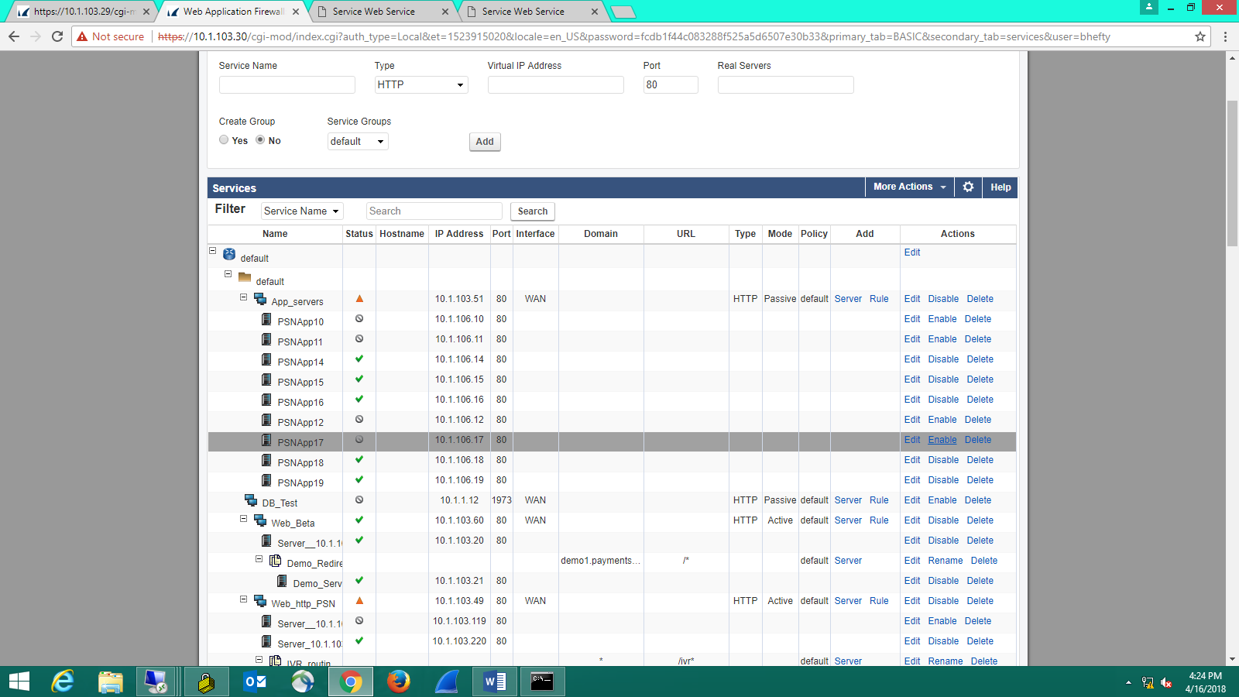

8. Restart the Monitor on 106.12 server.

**If there’s any issue, please contact the following support team in the order shown below:**

1. Bryan H.

2. Andrew F.

3. Norman E.